Create MariaDB DB on EC2

mariaDB is RELATIONAL DATABASE SERVICE

First create a instance

And inside instance install maria-db service

CONNECT to the instance

And I have installed mariadb using

Yum install -y mariadb105-server
systemctl enable mariadb
systemctl start mariadb

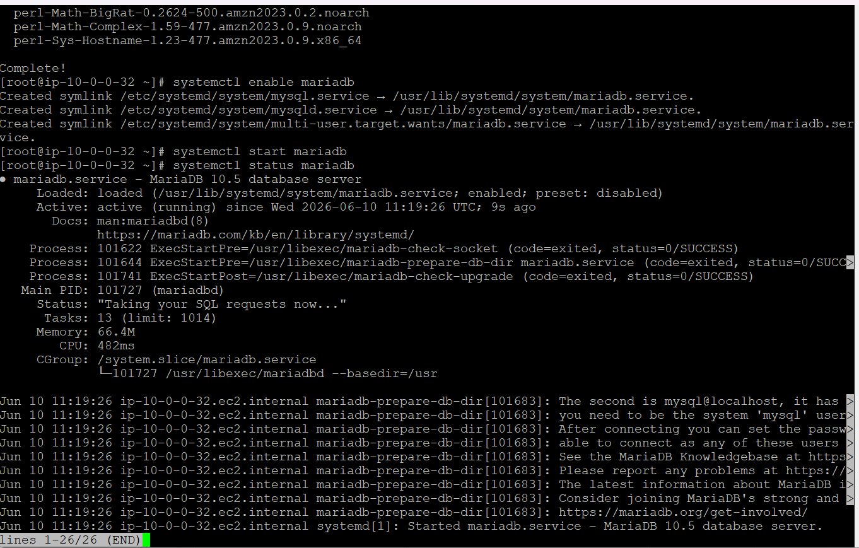

Will be giving variable to call out later

DBName=mariaDBec2
DBPassword=admin123456
DBRootPassword=admin123456
DBUser=xbox

Created a new file with the following commands to create the data base
Creating database and creating user with password for root and database

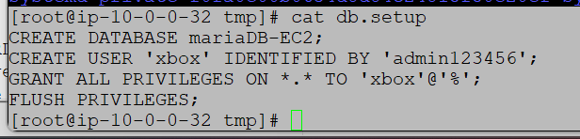

rm /tmp/db.setup

Using

mysql -u root --password="${DBRootPassword}"

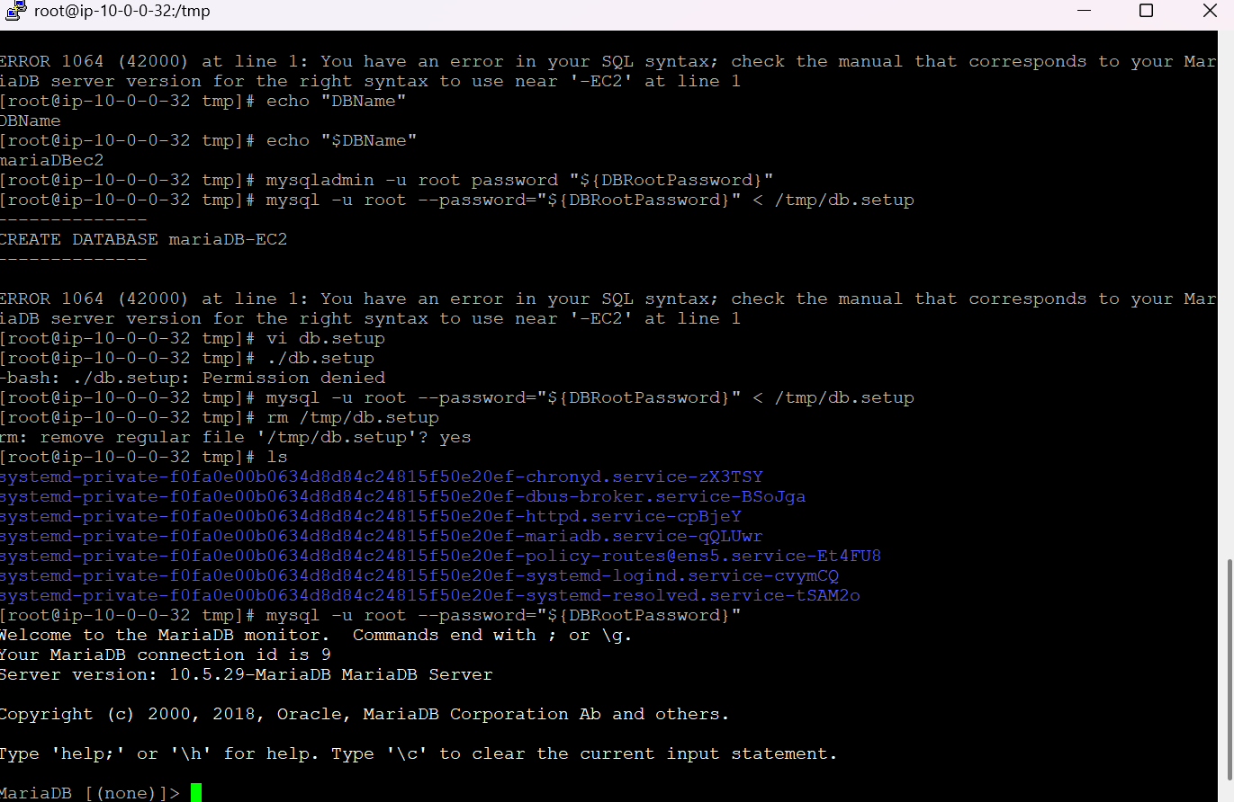

Now I have entered into maria DATABASE
Use show database;
To list the available databases in MARIADB

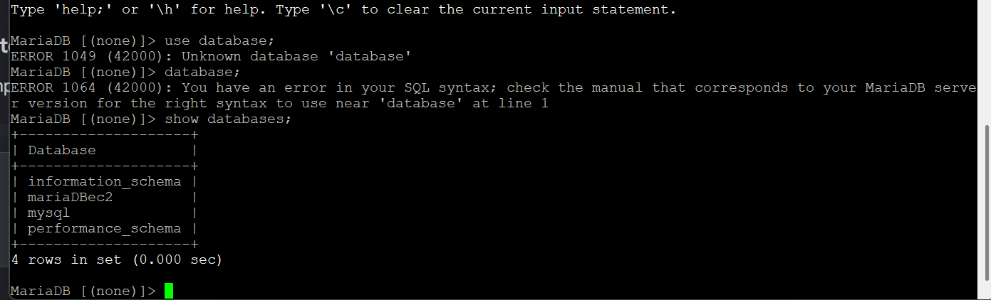

Insert some dummy data

In above step I have created a database
And now
I will be adding dummy data into the database mariaDBec2

mysql -u root --password="${DBRootPassword}"
---to login to the database

USE mariaDBec2;
To checkin to the database

CREATE TABLE table1 (id INT, name VARCHAR(45));
-----to create a table in database

INSERT INTO table1 VALUES(1, 'Virat'), (2, 'Sachin'), (3, 'Dhoni'), (4, 'ABD');
----to insert dummy data into table1 inside database

SELECT * FROM table1;

It will give out the data inside table

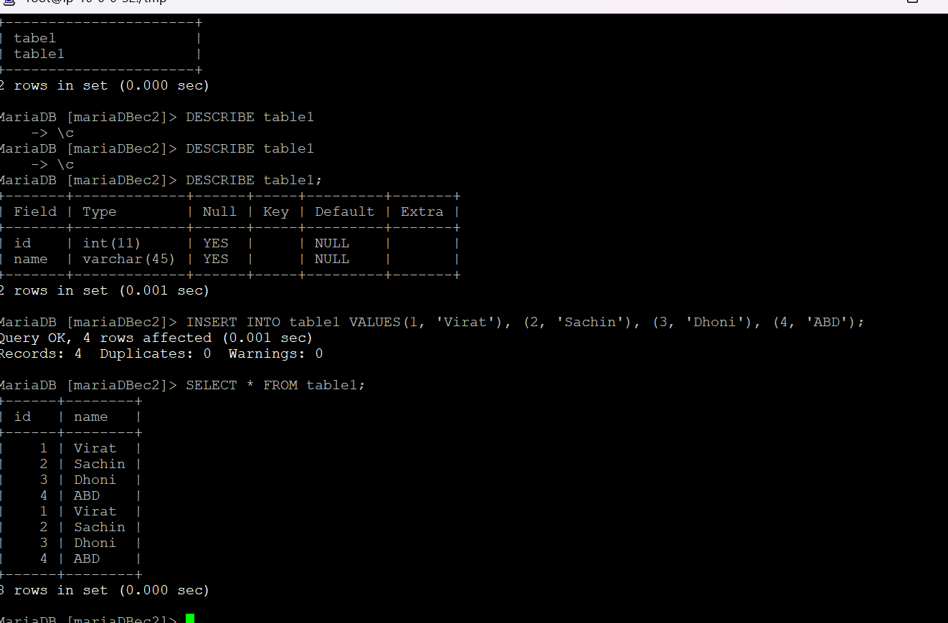

Take the backup of dummy data on EC2

To take a backup of mariaDBec2 database on your Amazon EC2 instance.

I Will use the mysqldump command line tool.

mysqldump -u root -p mariaDBec2 > /tmp/mariaDBec2_backup.sql

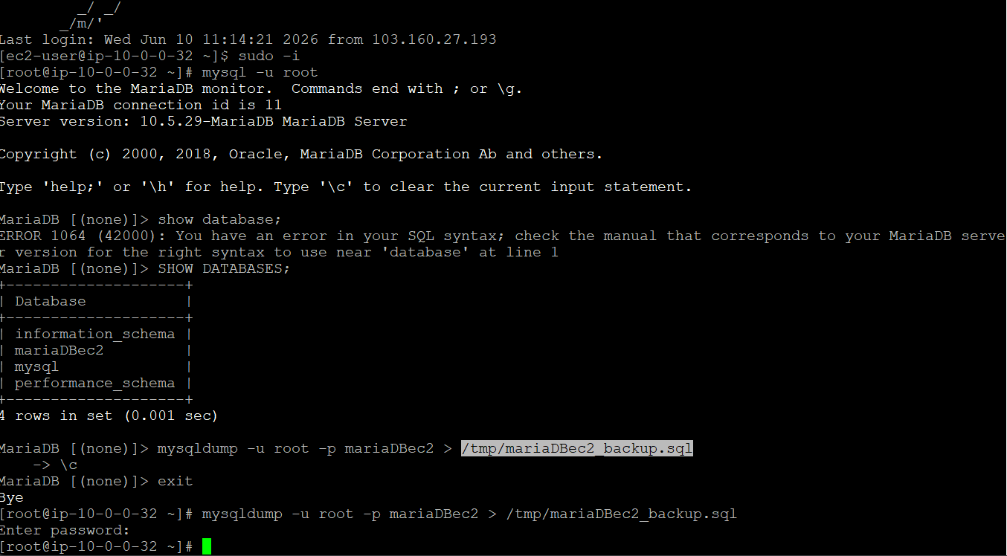

I have logged out of my database then I need to run the command
MYSQLDUMP

mysqldump -u root -p mariaDBec2 > /tmp/mariaDBec2_backup.sql

So now my backup database has been created in tmp in my ec2 instance

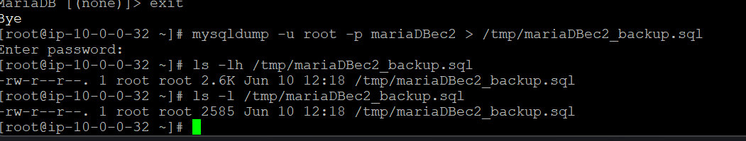

We can a backup has been created

Launch MariaDB RDS instance

Launching a new RDS database with maria

Open rds
↓
Select maria
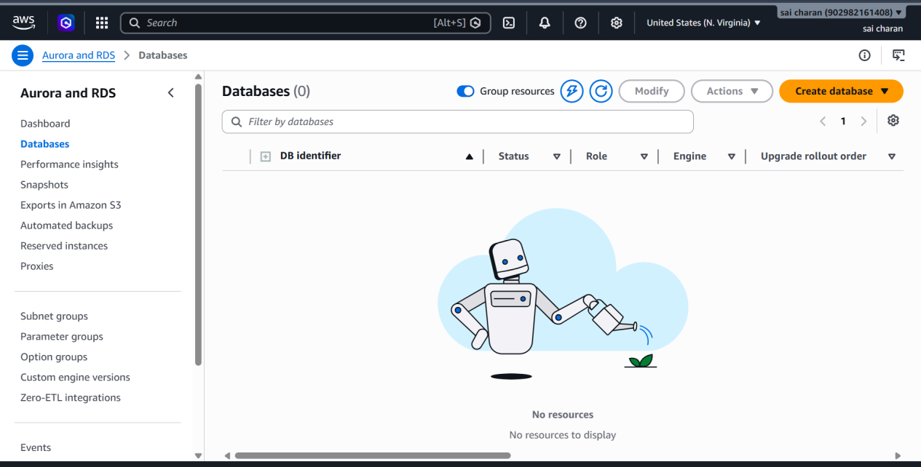

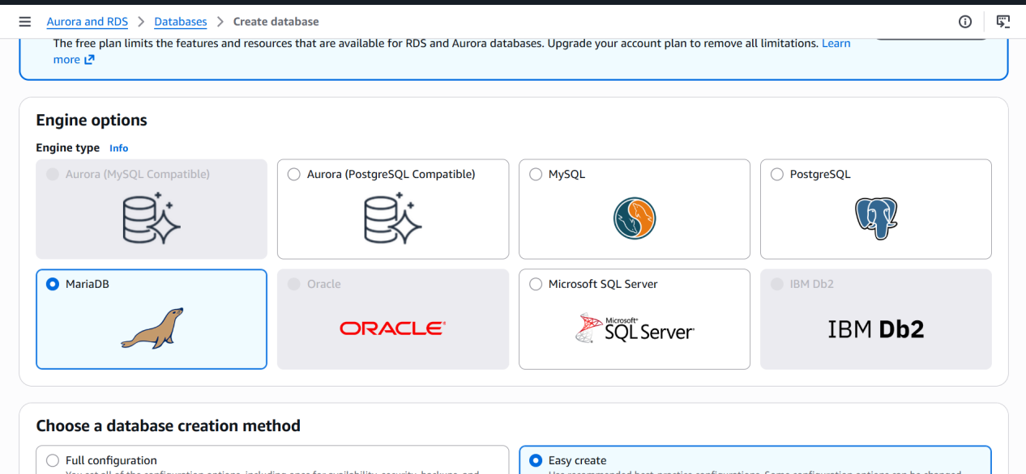

Select vpc that has more than 2 available zones for subnets
Then create database
I have used full configuration here MULTI-AZ is unavailable

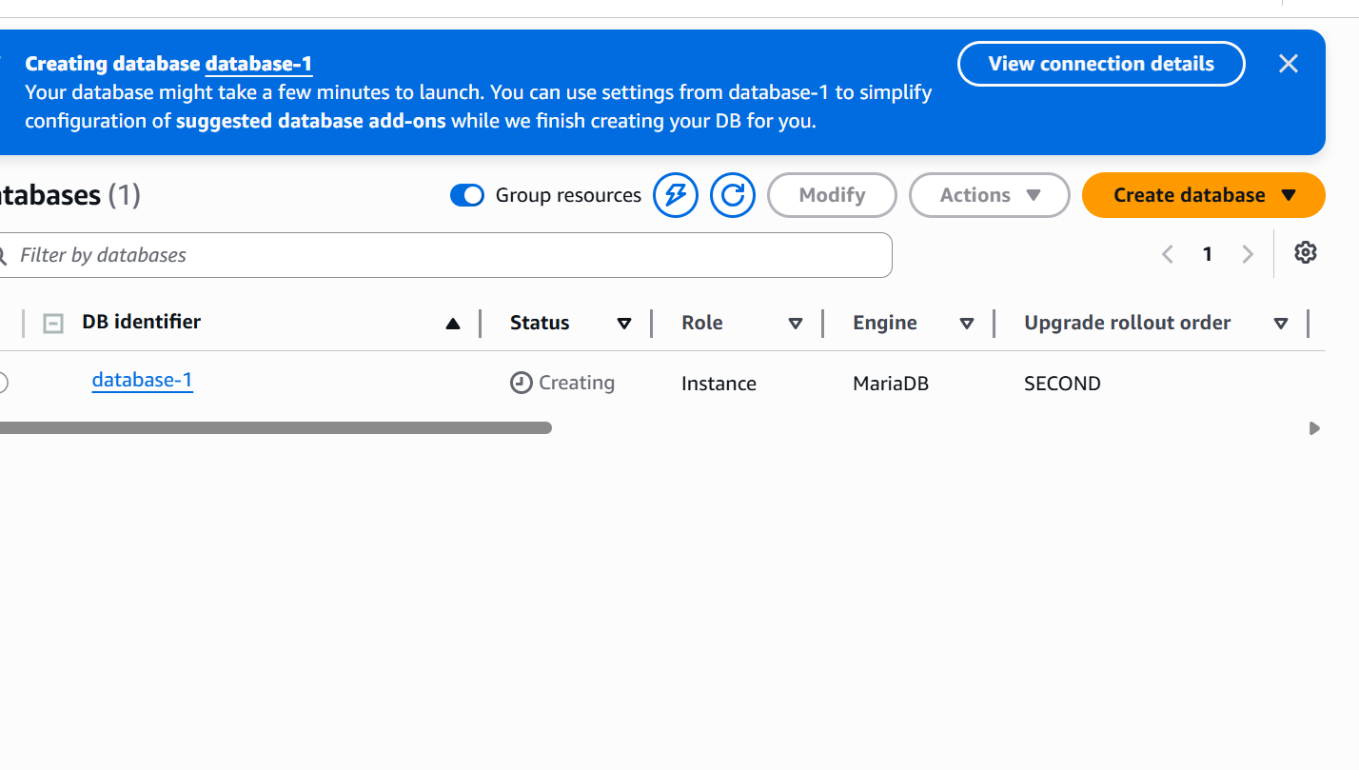

Migrate database from EC2 to RDS

Previously we have created maria DB in ec2 instance

Now I have created a RD MARIA DATABASE

I want to migrate mariadb in EC2 to mariadb in RDS

Get the dump of your existing DB on EC2

mysqldump -u root -p database_name > file_name.sql

----this helps to create the backup of your database in ec2 instance to .SQL file

Then dump this file into RDS database

mysql -h <replace-rds-end-point-here> -P 3306 -u <user_name> -p master-name < backup.sql

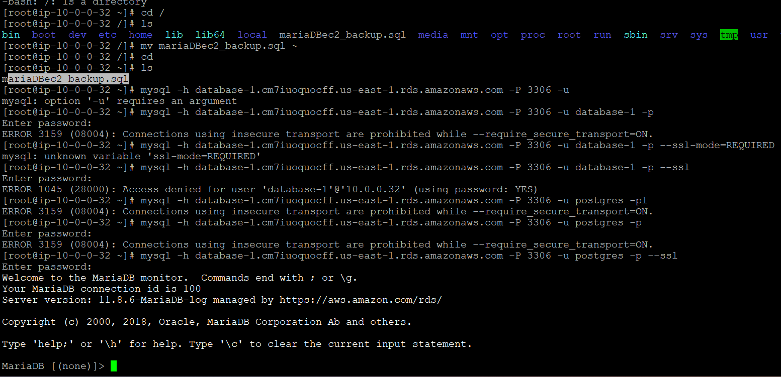

I have created a database in RDS DATABASE
Login to RDS DATABASE using

mysql -h database-1.cm7iuoquocff.us-east-1.rds.amazonaws.com -P 3306 -u postgres -p --ssl

Create database and exit
Then from root ec2 dump backedup ec2DB into RDS database

mysql -h database-1.cm7iuoquocff.us-east-1.rds.amazonaws.com -P 3306 -u postgres -p --ssl mariaDBec2D < mariaDBec2_backup.sql

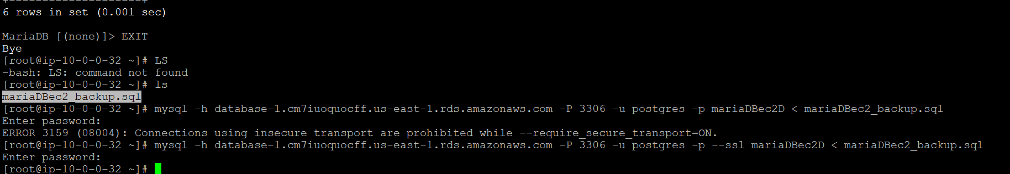

Now we have dumped ec2 DATABSE into RDS

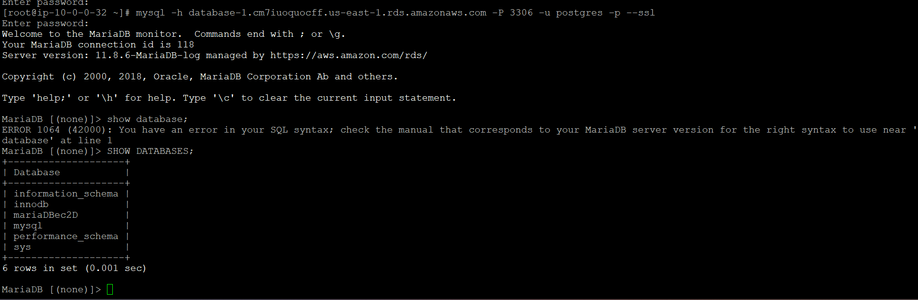

Install MySQL DB on EC2

Connect to the instance

And first we need to allow mysql traffic to the instance edit inbound rules

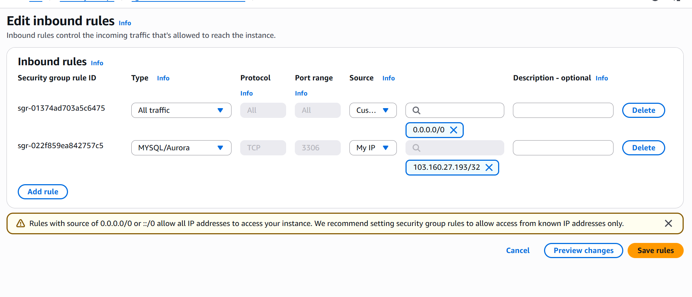

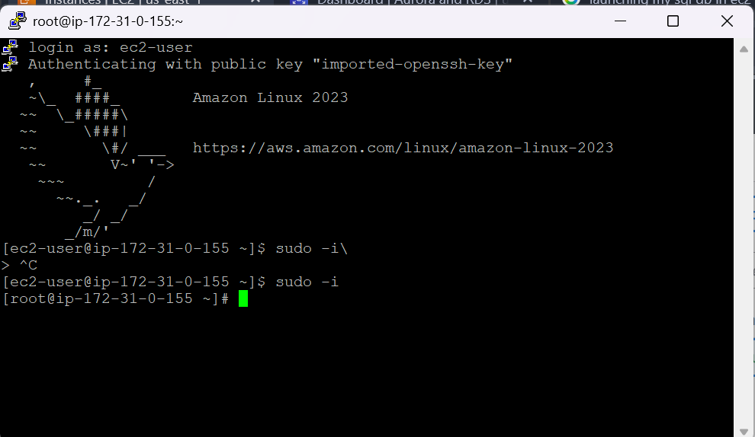

Connect to the instance and install first mariadb--server

sudo yum update -y

sudo yum install mariadb105-server -y

Then use the below commands to install mysql in instance

sudo yum update -y

sudo wget https://mysql.com

sudo yum localinstall mysql80-community-release-el7-5.noarch.rpm -y

sudo yum install mysql-community-server -y

Or
Just install mariadb105-server

And use

Systemctl enable mariadb

Systemctl start mariadb

Then install mysql

Use---

sudo mysql_secure_installation

Then give the speciffic permissions

Complete the setup

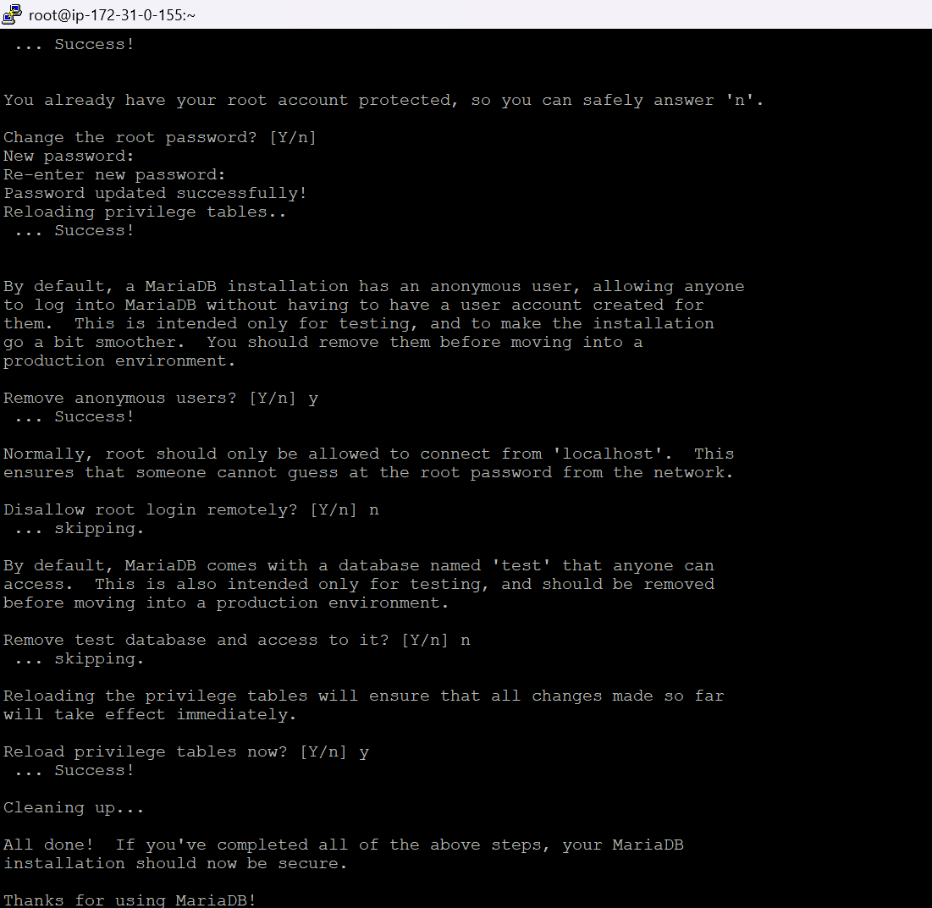

Now mysql has been installed in ec2

To login use ---- mysql -u root -p or mysql -u root

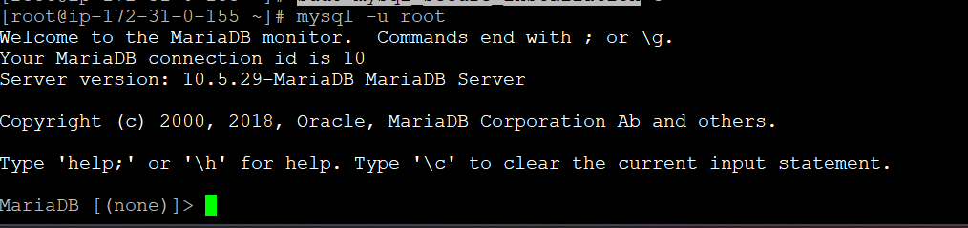

We have entered the mysql database

We can check the mysql --version
if mysql is installed or not

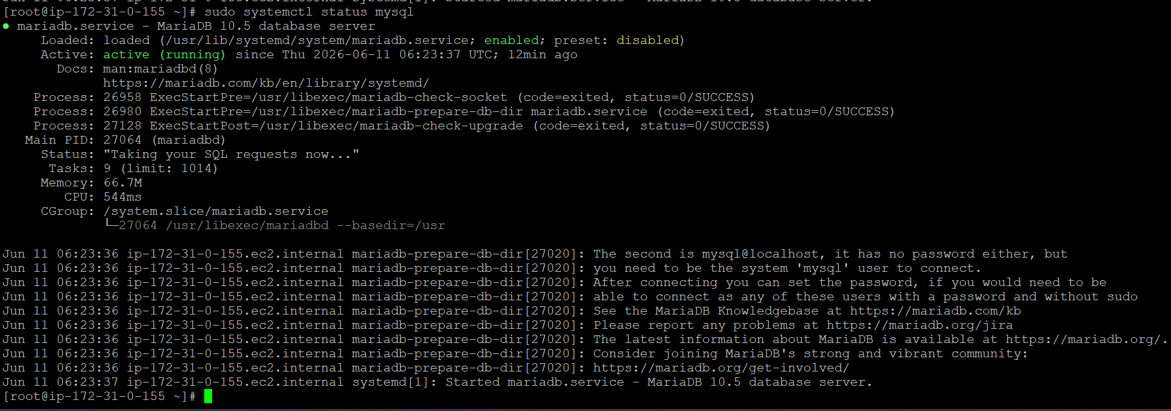

Launch MySQL RDS image

Creating a new RD database With my sql image

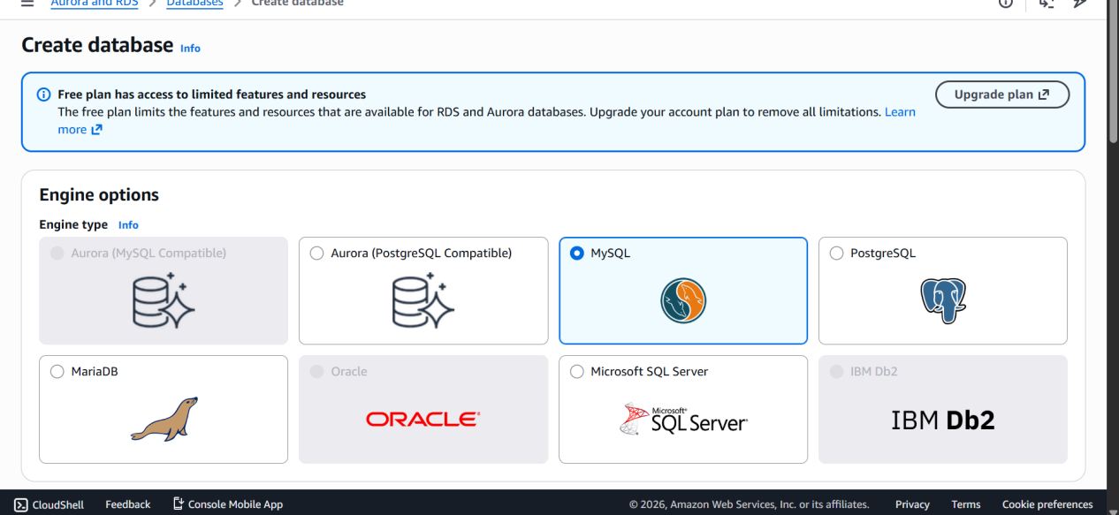

Give master username that can be used to login to our mysql rds

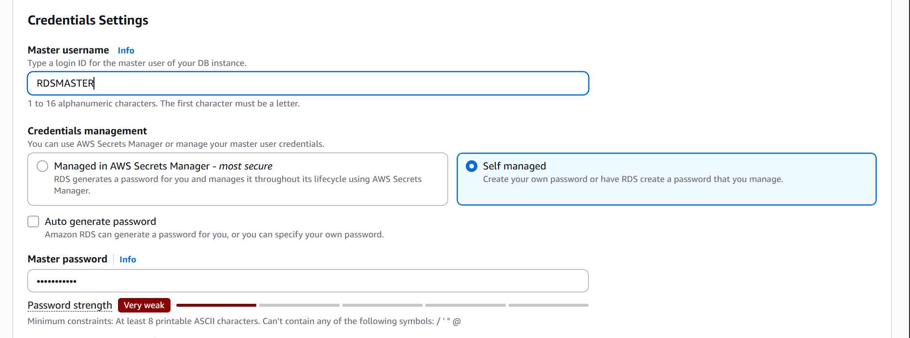

We can either connect to the instance now or later

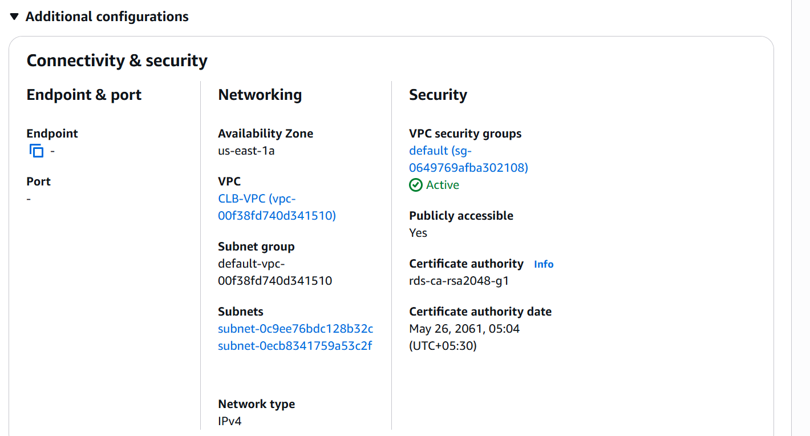

To launch an RDS database it should have min 2 AZ’s

I have launched an RDS WITH MYSQL AS IMAGE

Note----if instance vpc and RDS VPC is different we need to first make VPC PEERING CONNECTION

Then we can connect to both

-------diff VPC ---PEERING CONNECTION----------
------if same vpc we do not need vpc peering---------

Thi will be applicable when I launch my RDS on private subnet then we need peering if launched on public then no need to give peering because the database is exposed to public

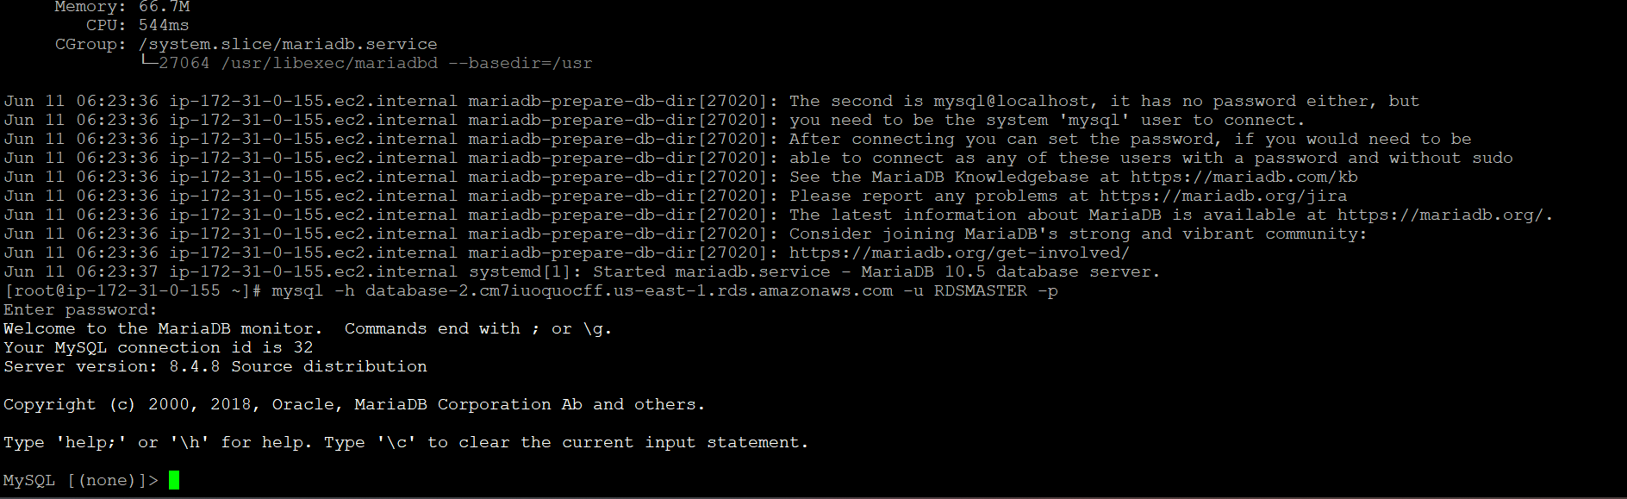

I have connected to rds from ec2 without peering connection because my database is in public subnet that has internet access

Configure Multi-AZ

multi-AZ acts as replication database for our primary database

The replicated database will be in another available zone

Which is why we call it as multi-AZ

The replicated database in other zone is always on standby it will be used when if primary database AZ is down or under maintenance then the standy database can be accessed

Standby cannot be accessed directly unless the primary databse is down

To configure multi-az we need to launch a database on full configuration

Create a database with enabling multi-AZ
As we can see it provides 99.95% uptime
And other database as standby
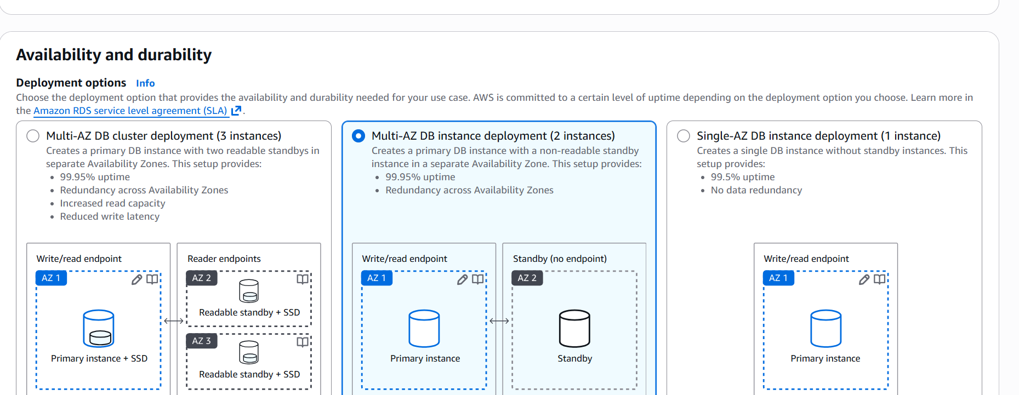

Then click on create database

Then standby instance has been created in other zone

Take backup of DB and restore the DB

I will be creating backup of database
Then after creating the backup using the backup I will be restoring the DB

To create a backup I will use snapshot of my present mysql image RDS

First I will create snapshot

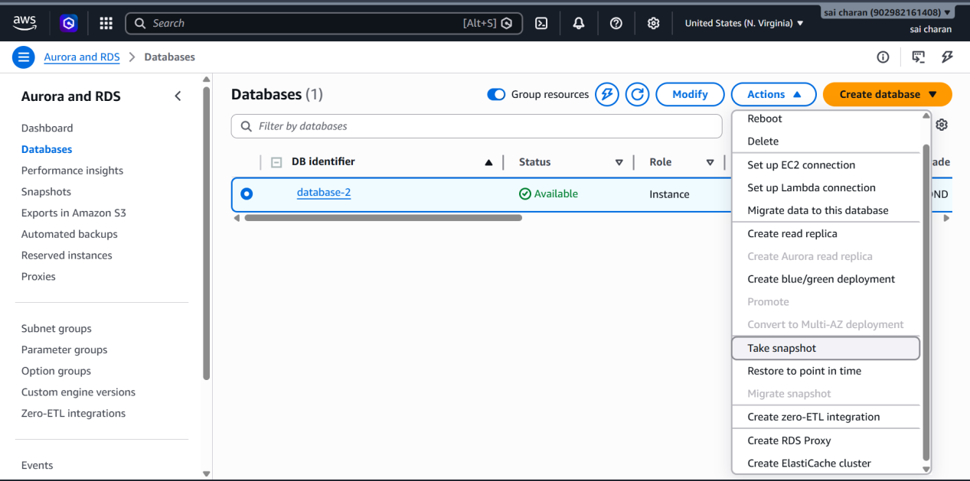

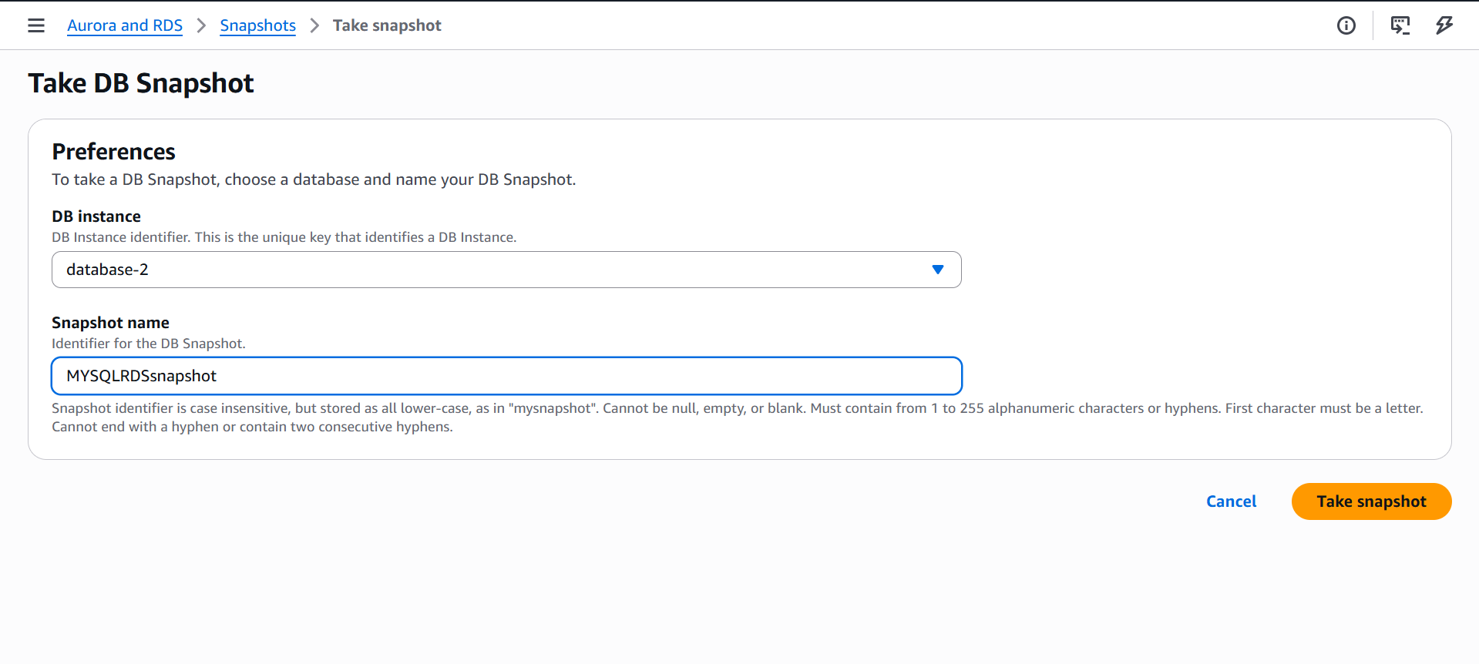

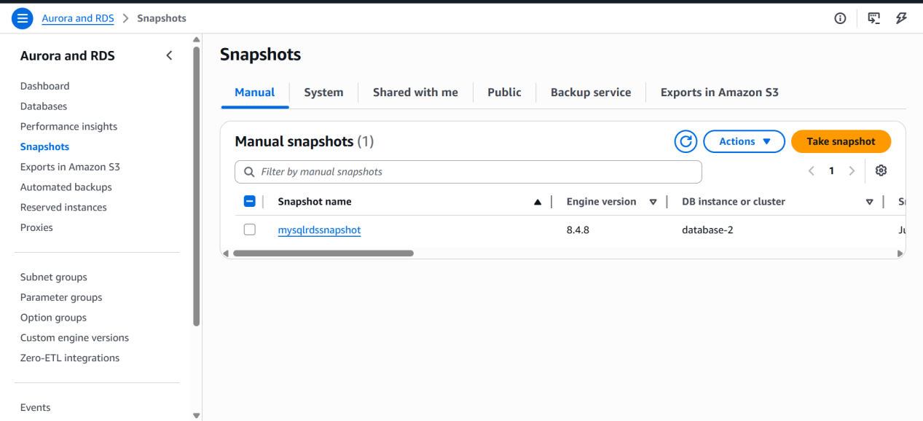

A new snapshot has been created for MYSQL image of RDS has been created

Using this snapshot I will restore my database

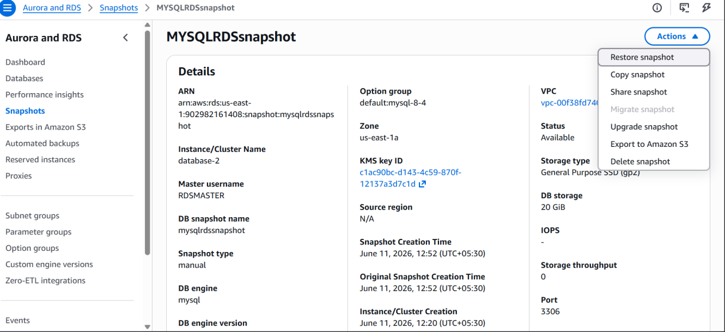

Click on restore snapshot

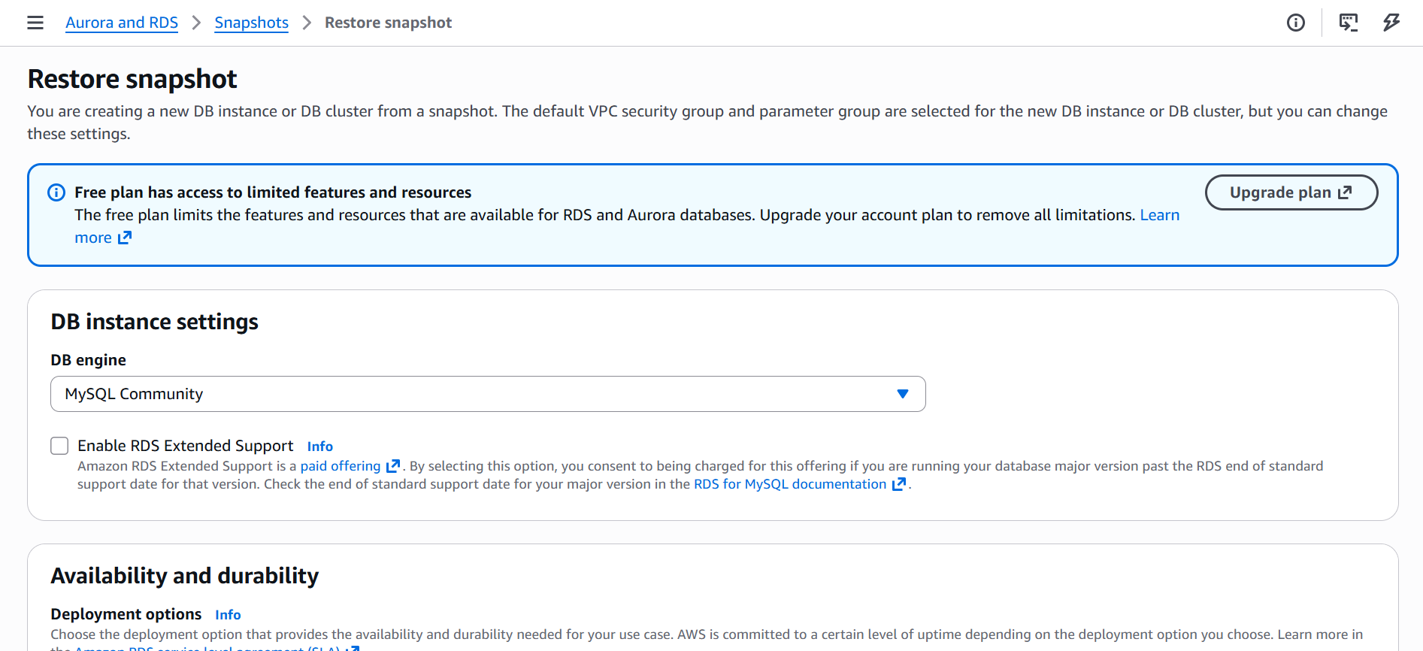

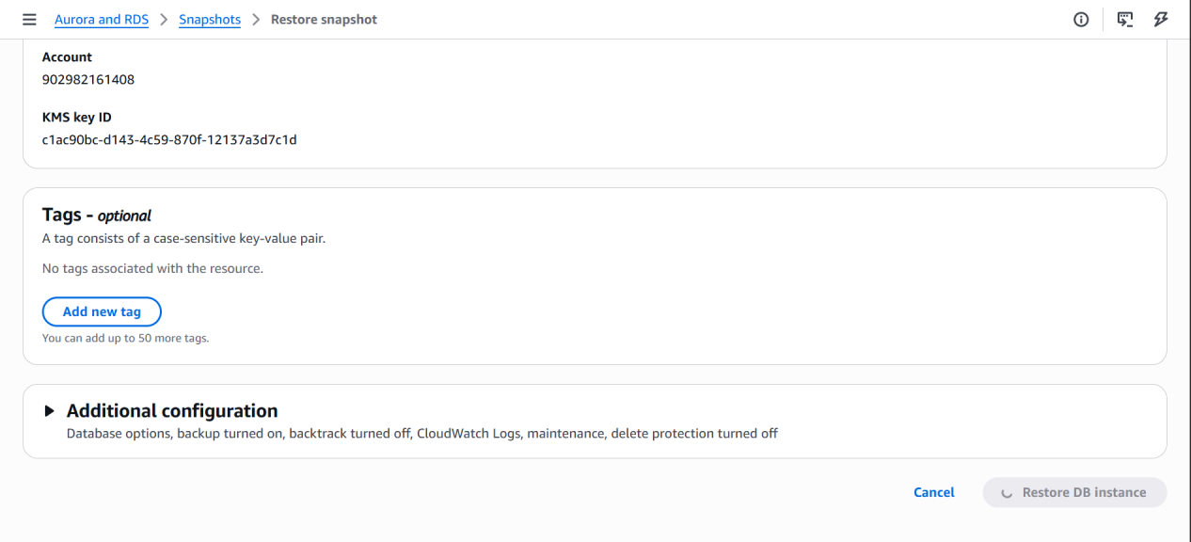

After configuration click on restore DB instance

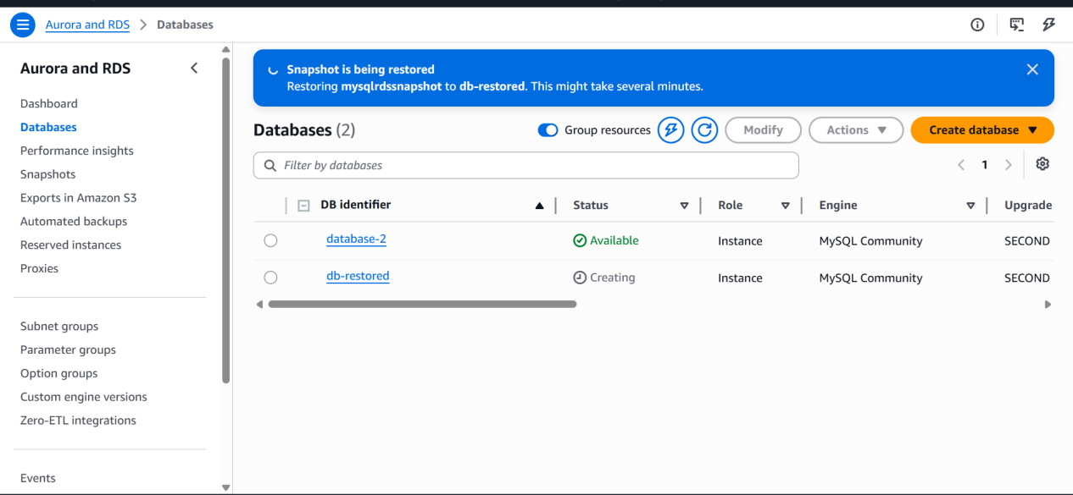

New database has been created using the backup of old database
And the endpoint will be changed for restored database

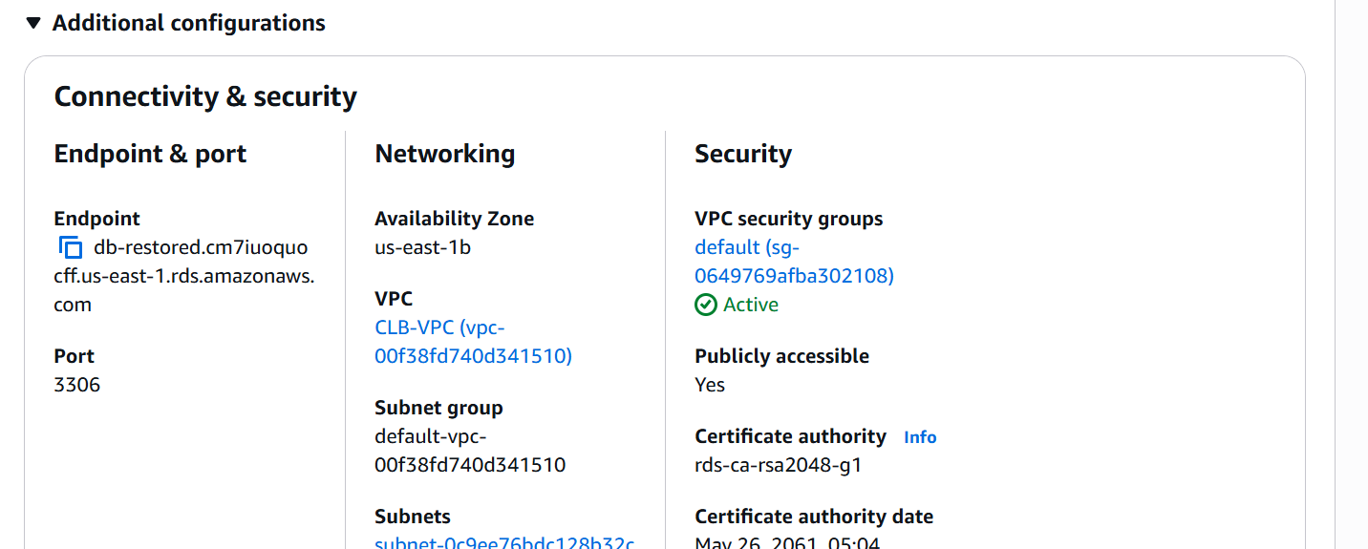

Create read replica

Read replicas are copy of primary instance

Read replica instance has only read access

And it will be in other available zone

Also used for backup of primary database

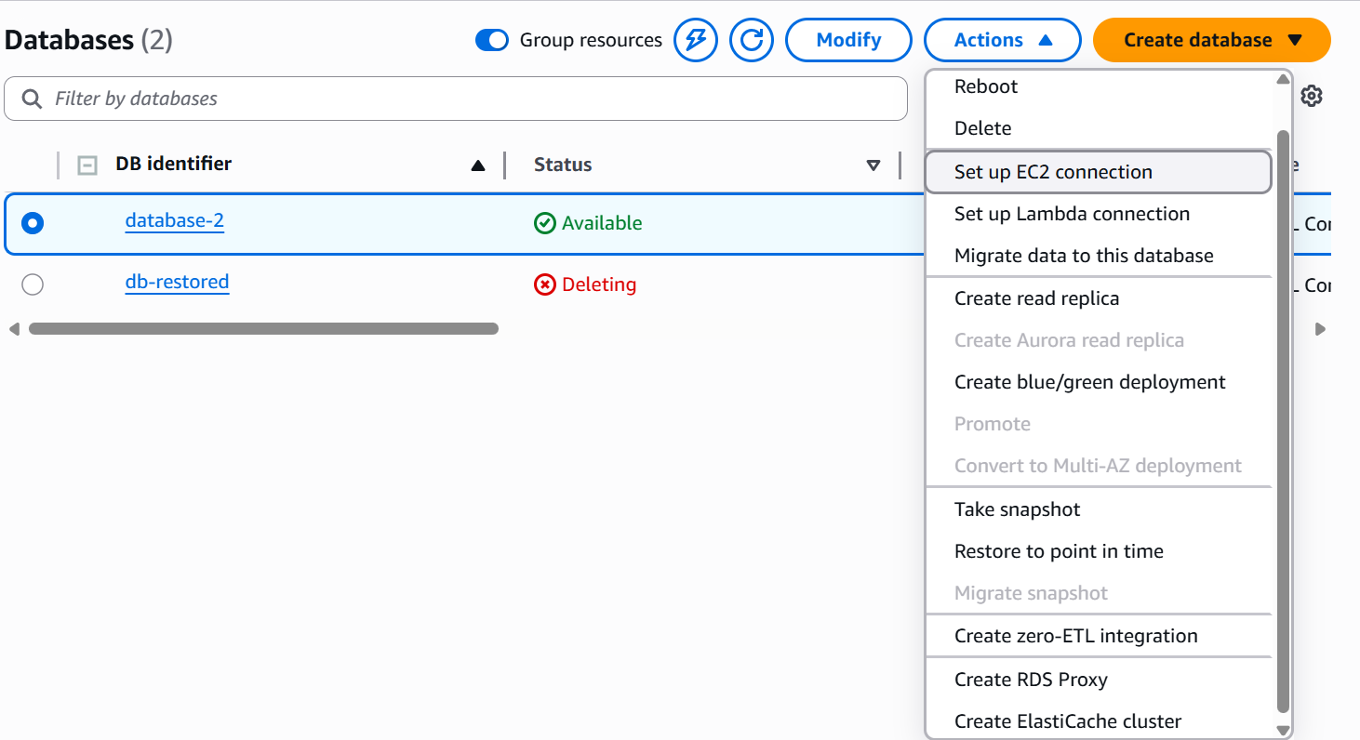

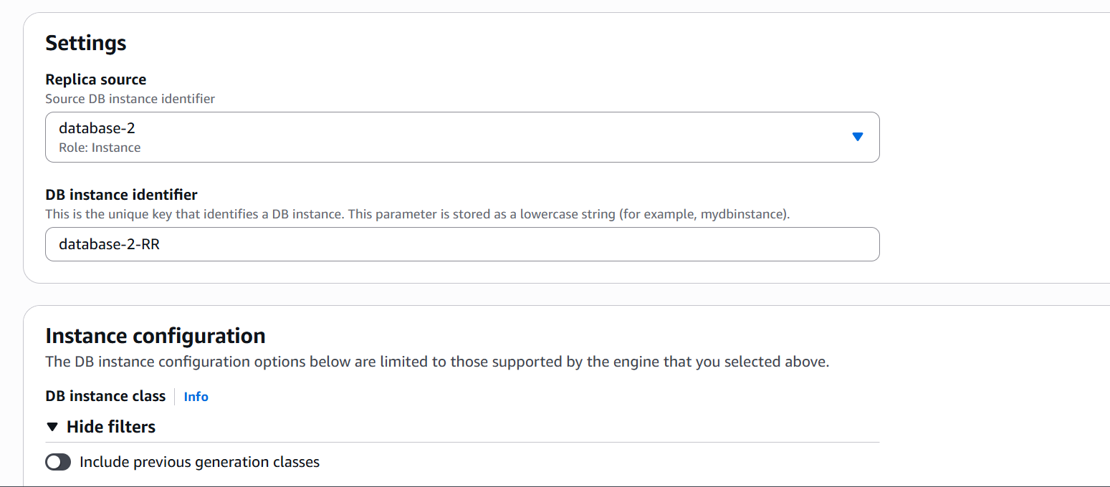

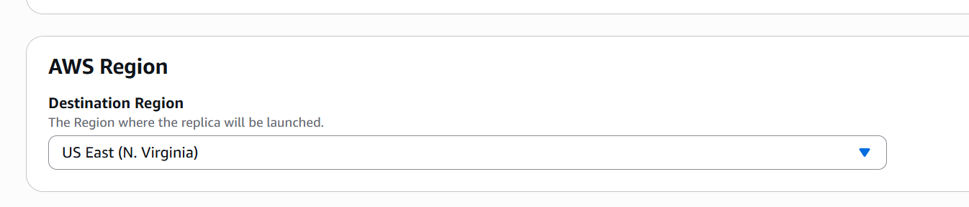

It should create in same region but in other subnet that has different zone

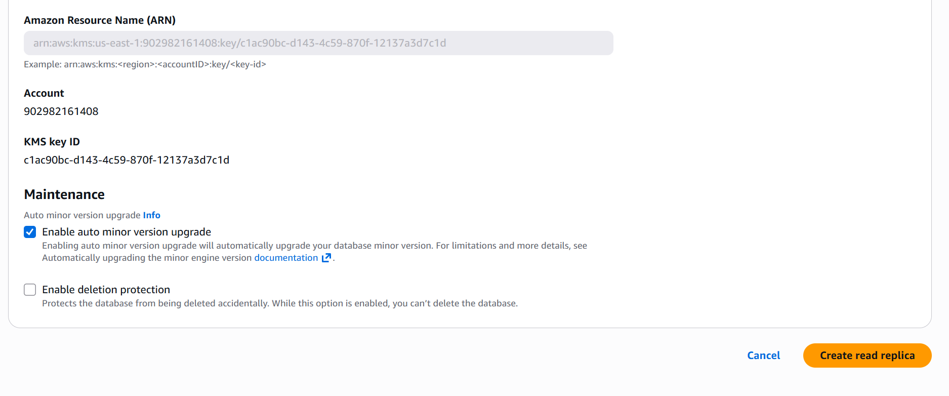
Now we can see under my database a new database has been created

It is read replica database

It has only read access

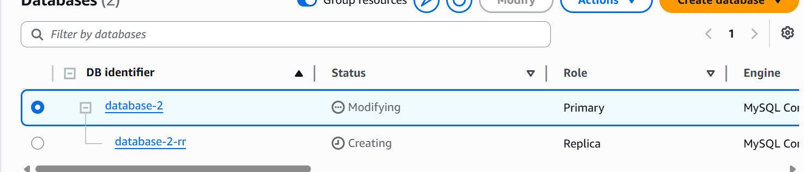

I will see first if the entire data in main database has been copied to RR or not

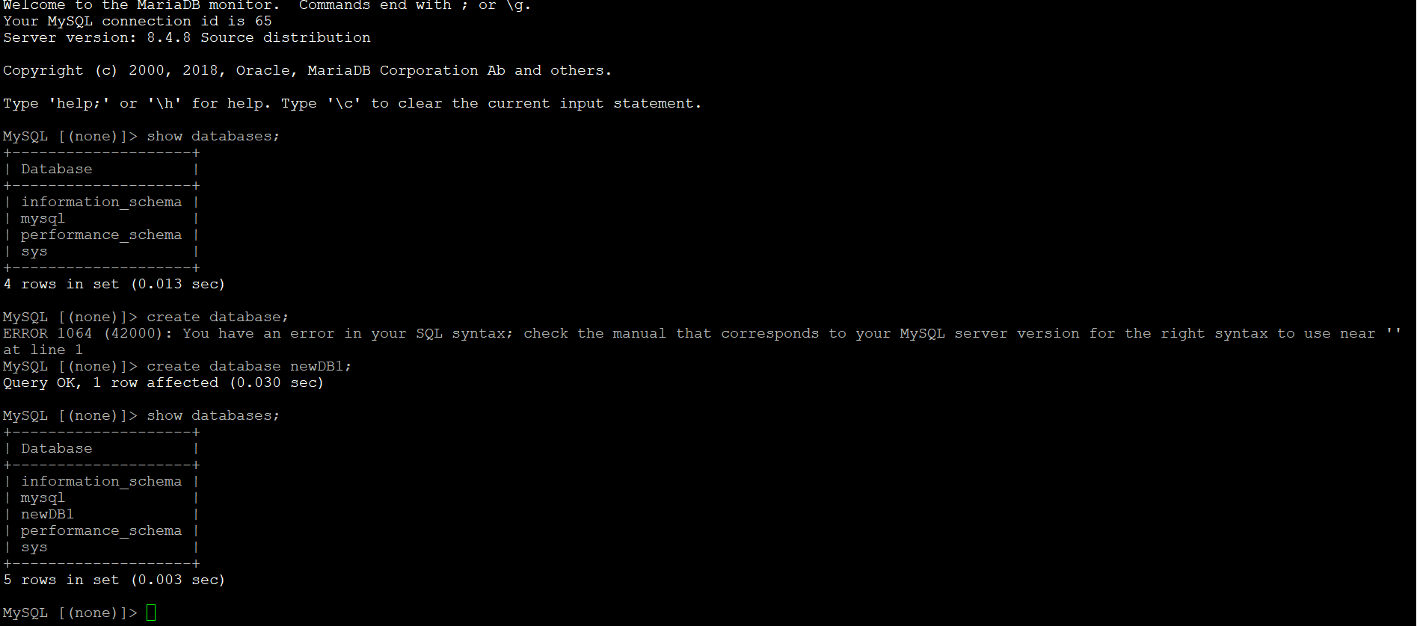

I have ceated a new database in rds

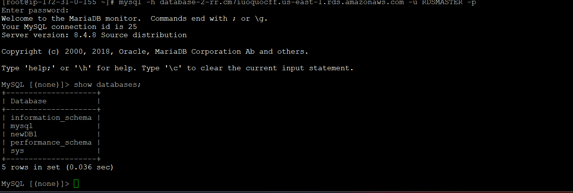

We can see it has been created in READ REPLICA database automatically

Same way any data given into main database the entire data will be replicated into the RR database

And it Requires automated backups enabled on Primary

